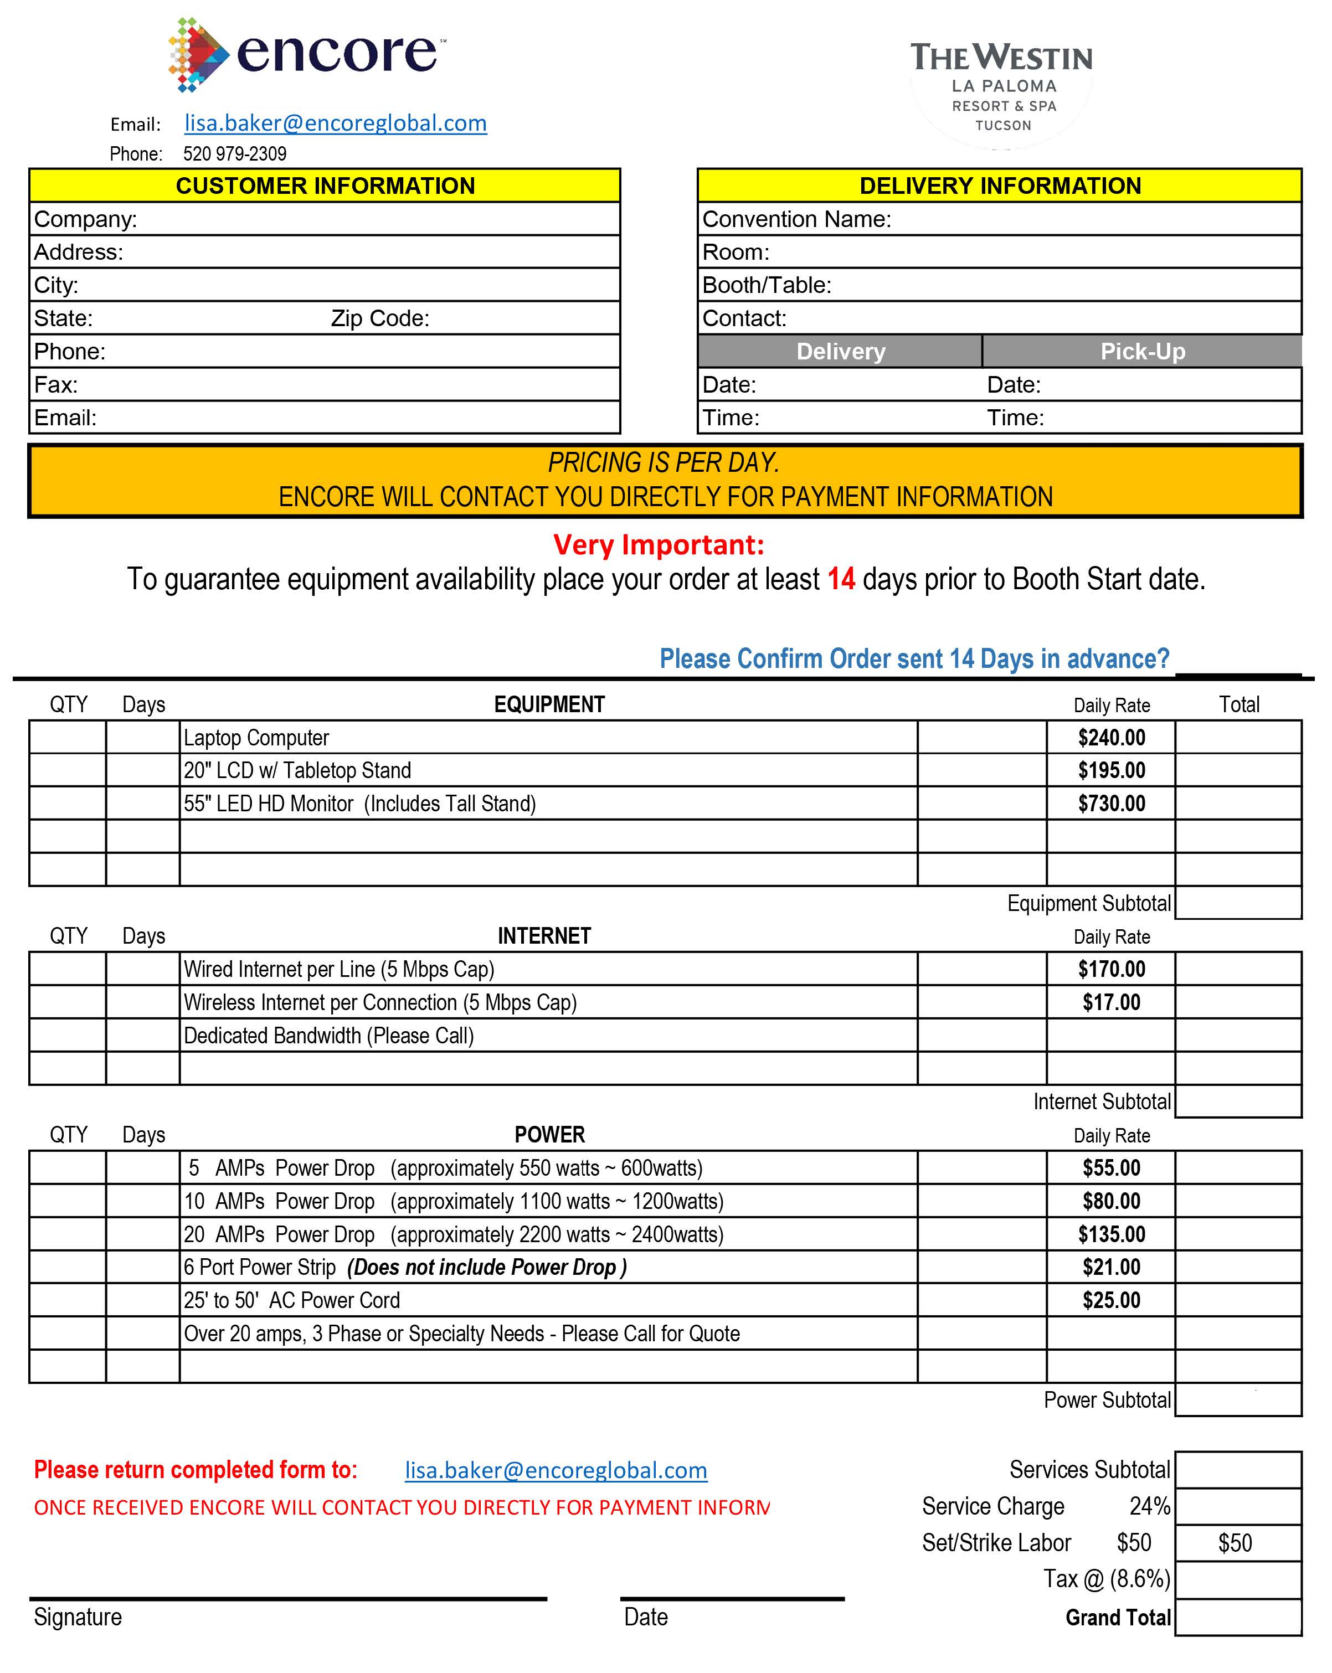

Send this form to the Weston La Paloma Resort
Shipping & Receiving

Package Center processing fee is 59 cents per pound for all packages received and destined for your conference. An itemized statement detailing the number of packages received, carrier name, total weight, and the processing fee is provided daily for your review. The processing fee includes the storage of packages up to seven (7) calendar days before your events. Packages stored for eight (8) calendar days or more will be assessed an additional processing fee of 25 cents per pound, per day. All charges are posted to the Group Master Account. La Paloma does not provide “second-party” billing; the actual sender of the package is not invoiced. Only the Master Account is invoiced for all convention packages received. It is your responsibility to recover processing fees from your convention participants if you desire. The information provided on the daily package manifest and processing invoice will assist you with this option.
The Package Center will process your out-going packages. Packages must be properly wrapped and addressed for shipment before any processing by the Package Center.
Shipping/handling fees are the responsibility of the sender. You may charge the shipping/handling fees to your Master Account if so authorized, or use your commercial carrier accounts.
Individuals who are not authorized signatures for the Master Account may add the shipping/handling fees to their room account before checkout. Additionally, we accept major credit cards or cash. A $5 per package handling charge will be applied to all packages not paid by the Master Account. Carrier services can be arranged with Federal Express or United Parcel Services.

Please contact
JILL MILLER
Convention Services Manager
jill.miller@westinlapaloma.com
520.577-5835

